Leicester Cathedral Gardens
- RonaDeck Resin Bound Surfacing

In brief
RonaDeck Resin Bound Surfacing was laid in Leicester Cathedral Gardens as part of a £2.5 million project transforming the city’s cathedral quarter and providing a connection to the new Richard III visitor centre.

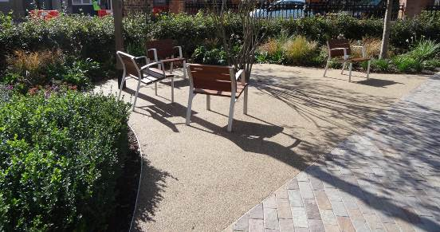The project
A new public space large enough to host outdoor events for up to 800 people has been created as part of the project. Included within the gardens are flower beds, trees and lawn areas, seating and a water feature. A statue of Richard III has been moved from Castle Gardens, restored and cleaned and placed at the centre of the Cathedral Quarter project closer to the Leicester car park where his body was found buried.
At the other end of the gardens is Towards Stillness, a sculpture comprising steel plates which tell the story of Richard’s time in Leicester from the Battle of Bosworth to the discovery of his grave in 2012.

Product and application
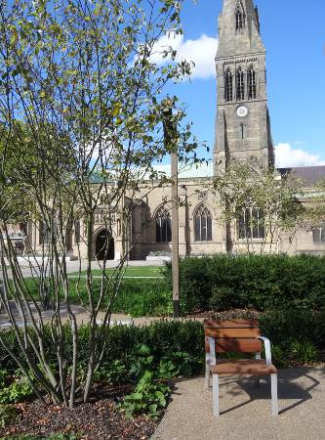The areas around the sculpture and the surrounding pathways have been landscaped with RonaDeck Resin Bound Surfacing as part of the re-development project. Ronacrete Approved Contractors Route One Highways laid around 350 square metres of RonaDeck Resin Bound Surfacing, using a Rustic Bronze aggregate blend.
RonaDeck Resin Bound Surfacing is a hard wearing, permeable (SuDS compliant) alternative to traditional paving and has the attractiveness of natural aggregate while being easily maintained unlike loose gravel. It is also suitable for wheel chairs and is slip-resistant.

Conclusion
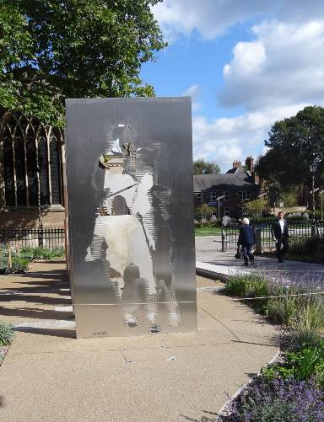RonaDeck Resin Bound Surfacing has played a role in creating an attractive public space that can be enjoyed by visitors to the cathedral or the Richard III visitor centre and the people of Leicester in general.

